Ex: 9 Cricketapp  
App.js

import './App.css';

import Listofeven from './components/Listofeven';

import Listofplayers from './components/Listofplayers';

import Mergedplayers from './components/Mergedplayers';

import Oddplayers from './components/Oddplayers';

import Playerlessthan70 from './components/Playerlessthan70';

function App() {

const players = [

  { name: "MS Dhoni", score: 45 },

  { name: "Sachin Tendulkar", score: 98 },

  { name: "Virat Kohli", score: 66 },

  { name: "Muttiah Muralitharan", score: 72 },

  { name: "Shane Warne", score: 33 },

  { name: "Jacques Kallis", score: 84 },

  { name: "Brian Lara", score: 59 },

  { name: "Yuvraj Singh", score: 91 },

  { name: "Glenn McGrath", score: 28 },

  { name: "Rahul Dravid", score: 75 },

  { name: "AB de Villiers", score: 47 },

];

  return (

    <div >

      <Listofplayers list={players}/>

      <Playerlessthan70 lessthan={players}/>

      <Oddplayers first={"MS Dhoni"}

        third={"Sachin Tendulkar"}

        fifth={"KL Rahul"}/>

      <Listofeven second={"Kohli"} fourth={"Dravid"} sixth={"Umesh Yadav"}/>

      <Mergedplayers list={players}/>

    </div>

  );

}

export default App;

Listofeven.js  
import React from "react";

function Listofeven({second,fourth,sixth}){

    return(

        <div>

            <h2>List of Even players</h2>

            <ul>

            <li>Second:{second}</li>

            <li>Fourth:{fourth}</li>

            <li>Sixth:{sixth}</li>

            </ul>

        </div>

    )

}

export default Listofeven;

Listofplayers.js  
import React from 'react';

function Listofplayers({list}){

    return(

<div>

    <h2>List of players</h2>

    <ul>

{list.map((list)=>(

<li>{list.name}-{list.score}</li>

))}

</ul>

</div>

    )

}

export default Listofplayers;

Margedplayers.js  
import React from "react";

function Mergedplayers({list}){

const arr=[...list];

const flattened=arr.flat();

return(

    <div>

        <h2>List of mergedplayers</h2>

        <ul>

            {flattened.map((players)=>(

                <li>{players.name}</li>

            ))}

        </ul>

    </div>

)

}

export default Mergedplayers;

Oddplayers.js  
import React from "react";

function Oddplayers({first,third,fifth}){

    return(

        <div>

            <h2>List of Odd players</h2>

            <ul>

            <li>First:{first}</li>

            <li>Third:{third}</li>

            <li>Fifth:{fifth}</li>

            </ul>

        </div>

    )

}

export default Oddplayers;

Playerslessthan70.js  
import React from "react";

function Playerlessthan70({lessthan}){

    return(

        <div>

<h2>List of players having score less than 70</h2>

<ul>

    {lessthan.map((player)=>(

        player.score <70 ?(

        <li>{player.name}- {player.score}</li>

    ):null

    ))}

</ul>

        </div>

    )

}

export default Playerlessthan70;

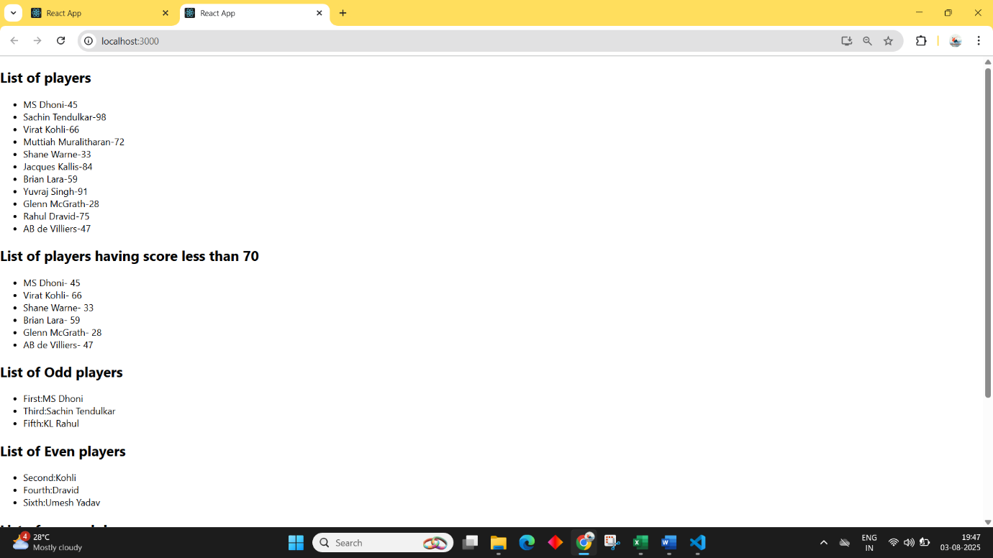Output:

10. Officespacerentalapp  
  
Code:  
App.js  
import Officedetails from "./components/Officedetails";

import React from "react";

function App() {

  return (

    <div className="App">

      <Officedetails/>

    </div>

  );

}

export default App;

Officedetails.js  
  
import React from "react";

function Officedetails(){

    const details=[

 {

      id: 1,

      name: "Downtown Office",

      rent: 55000,

      address: "123 Main St, Cityville",

      image: "https://www.exisglobal.com/wp-content/uploads/2023/03/open-closed-office-space-pros-cons.jpg"

    },

    {

      id: 2,

      name: "Tech Park Office",

      rent: 75000,

      address: "456 Tech Rd, Silicon Town",

      image: "https://hubble.imgix.net/listings/uploads/spaces/10598/01b11526872873ee7c956caeea118b22-NE_Unit_2.jpeg"

    },

    {

      id: 3,

      name: "Corporate Space",

      rent: 60000,

      address: "789 Business Ave, Metropolis",

      image: "https://etimg.etb2bimg.com/photo/115974739.cmhttps://media.istockphoto.com/id/1336357371/video/modern-office-interior-in-a-business-center-empty-open-office-space.jpg?s=640x640&k=20&c=pVwI8nODifa7vmu8yHu8CM8b2lAKFm-5ZXb_Rcboi2k="

    }

    ];

    const colours= details.map(office=>

        office.rent < 60000? 'red': 'green'

    )

    return(

        <div>

            <h2>Office space for rent</h2>

            {details.map((office,index)=>(

                <div>

                    <img src={office.image} style={{width:400 ,height:200 }}/>

                    <div>

                   Name: {office.name}<br/>

                  <span style={{color:colours[index]}}>Rent: {office.rent}</span><br/>

                   Address:{office.address}<br/>

                </div>

                </div>

            ))

            }

        </div>

    )

}

export default Officedetails;

Output:  
  
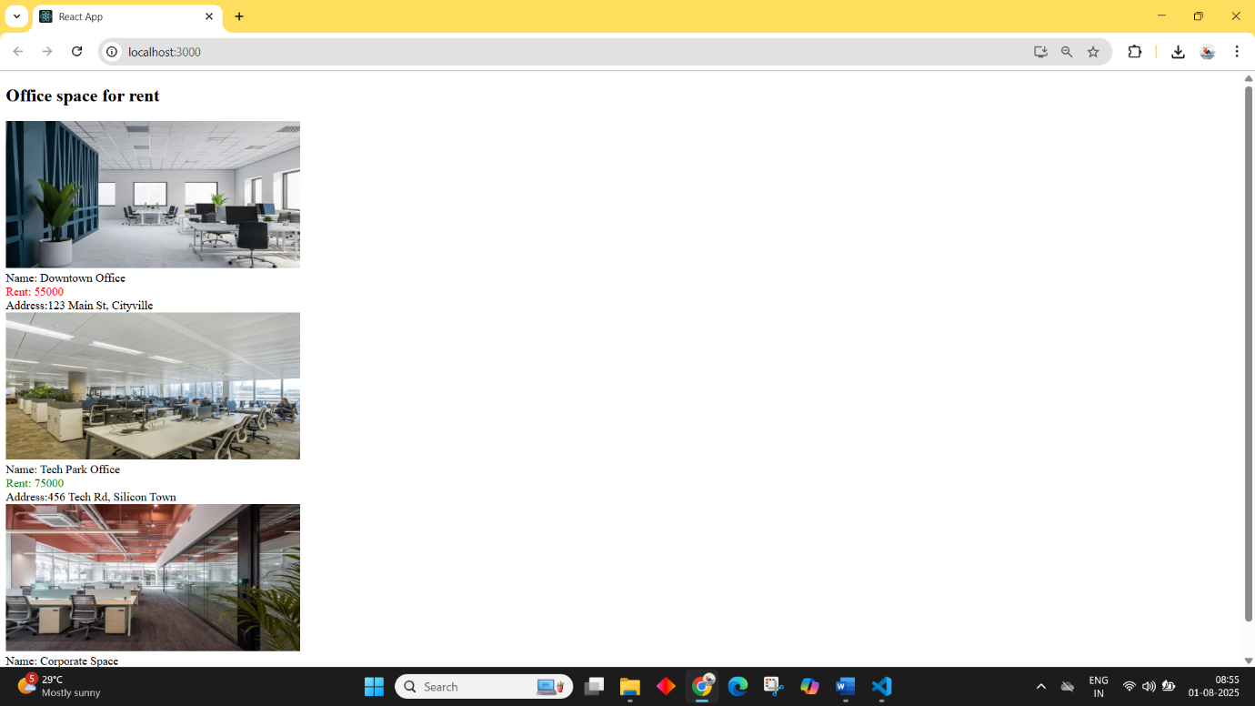

11. Eventexamplesapp  
  
Code:  
App.js  
import Page from './page'

import './App.css';

function App() {

  return (

    <div className="App">

      <Page/>

    </div>

  );

}

export default App;

Page.js

import React, { use, useState } from "react";

function Page(){

const[num,setNum]=useState(0);

const[count,setCount]=useState(0);

const[amount,setAmount]=useState(0);

function increment(){

setCount(count+1);

};

function decrement(){

    setCount(count-1);

}

function saywelcome(){

    alert("Hello, Welcome user!")

}

function clickedme(){

    alert("I was clicked")

}

function convertcurrency(){

    const conv=(num*0.011).toFixed(2)

setAmount(conv)

alert(`Currency converted to euro is ${conv}`);

}

return(

<div>

    <div>Count :{count}</div>

    <div><button onClick={increment}>Increment</button></div>

    <div><button onClick={decrement}>Decrement</button></div>

    <div><button onClick={saywelcome}>Say Welcome</button></div>

    <div><button onClick={clickedme}>Click me!</button></div>

    <h2 style={{color:"green"}}>Currency Converter</h2>

    <div>Amount:

        <input type="number" value={num} onChange={(e)=>{setNum(Number(e.target.value))}}></input>

    </div>

    <div>

       Currency: <input type="text"></input>

        <div><button onClick={convertcurrency}>Submit</button></div>

    </div>

</div>

    )

}

export default Page;

Ex:12 TIcketBookingapp  
  
Code:

App.js

import { useState } from 'react';

import './App.css';

import Login from './Login';

import Logout from './Logout';

function App() {

  const[login,setLogin]=useState(false);

  function toggle(){

    setLogin(!login)

  }

  return (

    <div className="App">

    <button onClick={toggle}>

      {login?"Login":"Logout"}

      </button>

      {login?<Login/>:<Logout/>}

    </div>

  );

}

export default App;

Login.js  
import React from "react";

function Login(){

    const flightProducts = [

  {

    id: 1,

    image: "https://upload.wikimedia.org/wikipedia/commons/thumb/4/45/VT-JRF_%40_JFK%2C_2024-11-04.png/500px-VT-JRF_%40_JFK%2C_2024-11-04.png",

    flightName: "Air India AI202",

    source: "Delhi (DEL)",

    destination: "Mumbai (BOM)",

    fare: 4500

  },

  {

    id: 2,

    image: "https://igiairport.in/wp-content/uploads/2025/03/IndiGo-Airlines.jpg",

    flightName: "IndiGo 6E301",

    source: "Chennai (MAA)",

    destination: "Bangalore (BLR)",

    fare: 2200

  },

  {

    id: 3,

    image: "https://aviationtoday.in/wp-content/uploads/2025/03/1278px-VT-SLH_-_Boeing_737-8AS_-_SpiceJet_-_33597_-_VGHS.jpg",

    flightName: "SpiceJet SG505",

    source: "Hyderabad (HYD)",

    destination: "Kolkata (CCU)",

    fare: 3800

  }

];

    return(

        <div>

            {flightProducts.map((flight,index)=>(

                <div>

                  <img src={flight.image} alt="flightname" style= {{width:400,height:200}}></img>

                    <div>{flight.flightName}</div>

                    <div>{flight.source}</div>

                    <div>{flight.destination}</div>

                    <div>{flight.fare}</div>

                </div>

            ))}

        </div>

    )

}

export default Login;

Logout.js  
import React from "react";

function Logout(){

return(

    <div>

        <h2>You are logged out, please login by clicking the button</h2>

    </div>

)

}

export default Logout;

Output:  
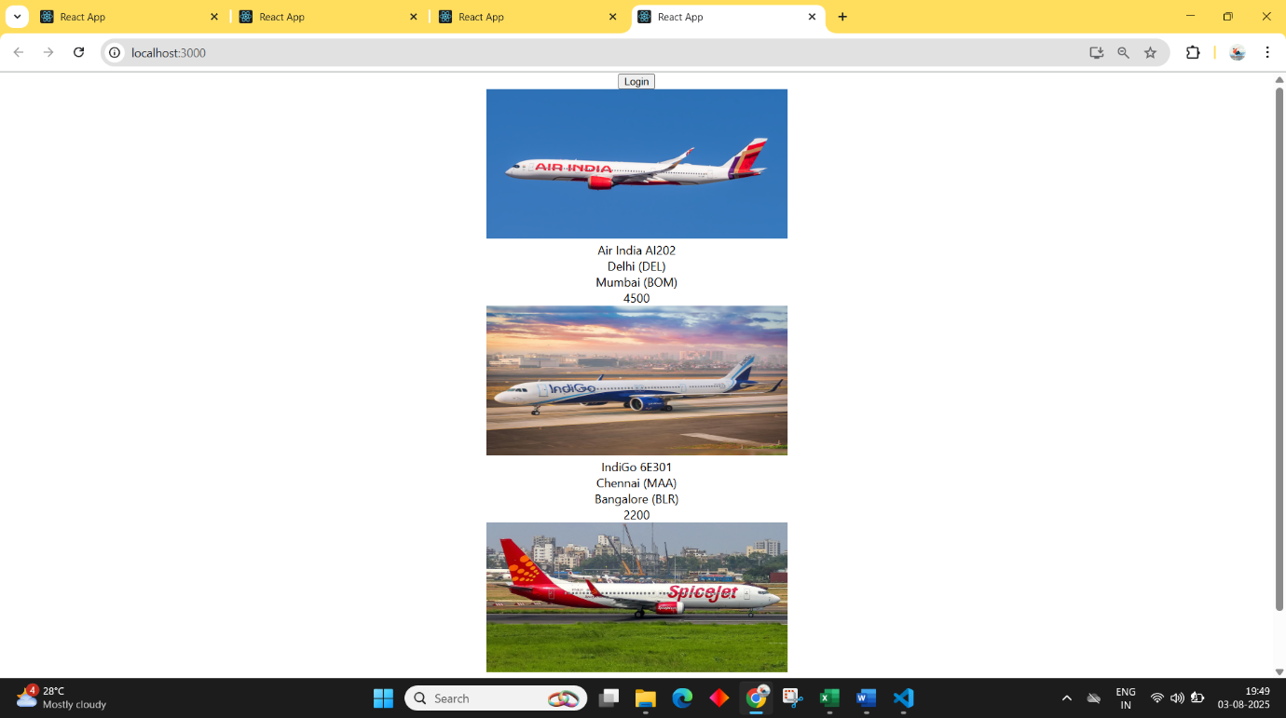  
  
Ex: 13 Bloggerapp  
  
Code:

import './App.css';

import Blogdetails from './Blogdetails';

import Books from './Books';

import Courses from './Courses';

function App() {

  const books=[{

    name: "Atomic Habits",

    price: 500

  },{

    name:"Psychology of money",

    price: 247

  },{name:"Good Dad, Bad Dad",

    price:180

  }];

const courses=[

  {

    name:"React Developer",

    date:"10/05/25"

  },{ name:"Node Js Basics",

    date:"29/02/24"},

    { name:"Spring Advanced",

    date:"31/06/26"}

];

const blogs=[{name:"Hill Climbing",

  author:"Jacob Roy",

  desc:"Adventures of jacob in mountains"

},

{name:"Sea Fishing",

  author:"Kumar Bejoy",

  desc:"Basic skills required to start fishing"},

  {name:"Forest Camping",

  author:"Vikram Deva",

  desc:"Survival skills in the deep woods of the forest"}]

  return (

    <div className="App">

      <div><Courses courses={courses}/></div>

     <div className="greenline"></div>

     <div><Books books={books}/></div>

     <div className="greenline"></div>

     <div><Blogdetails blogs={blogs}/></div>

    </div>

  );

}

export default App;

Blogdetails.js  
import React from "react";

function Blogdetails(props){

    return(

        <div>

            <h1>Blog Details</h1><br></br>

            {props.blogs.map((blog)=>(

                <div>

                    <div><h2>{blog.name}</h2></div>

                    <div>{blog.author}</div>

                    <div>{blog.desc}</div>

                </div>

            ))

            }

        </div>

    )

}

export default Blogdetails;

Books.js  
import React from "react";

function Books(props){

    return(

        <div>

            <h1>Book Details</h1>

            {props.books.map((book)=>(

                <div>

                    <h2>{book.name}</h2><br></br>

                    <h4>{book.price}</h4>

                    </div>

            ))

        }

        </div>

    )

}

export default Books;

Courses.js  
import React from "react";

function Courses(props){

return(

    <div>

        <h1>Course Details</h1>

   { props.courses.map((course)=>(

            <div>

            <h1>{course.name}</h1><br></br>

            <h4>{course.date}</h4>

            </div>

    ))

}

</div>

);

}

export default Courses;

App.css  
.App{

display: flex;

 justify-content: center;

 gap:70px;

}

.App>div{

  justify-content: center;

}

.greenline{

  background-color: darkgreen;

  width:4px;

}

Output:  
